

**School of Computer Science Engineering and Information Systems (SCORE)**

**Winter Semester 2023-2024**

**BITE307P-SOFTWARE ENGINEERING LAB**

**LAB DA 3**

# SOFTWARE TESTING TOOL

PREPARED BY: PRASHANT | 21BIT0524

TESTING THE GUI

© Transcriptor & Summarizer, (2024)

**Testing Tool:** PyautoGUI

**Description**: A python based GUI testing module to automate clicks and test output.

**GUI Screenshot:**  
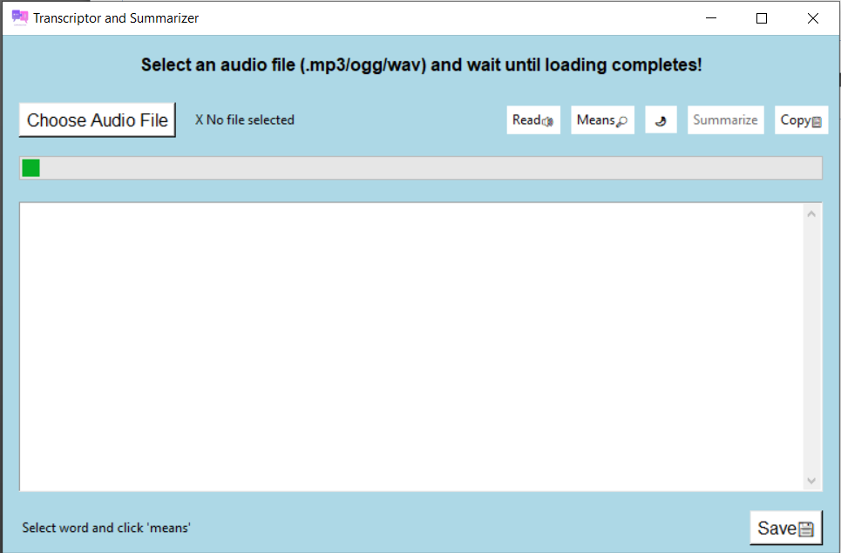

Live Testing screenshot:

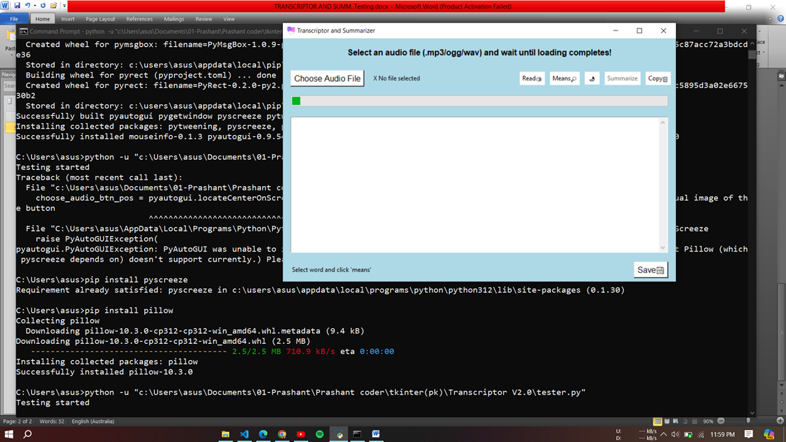

Testing choose file operation

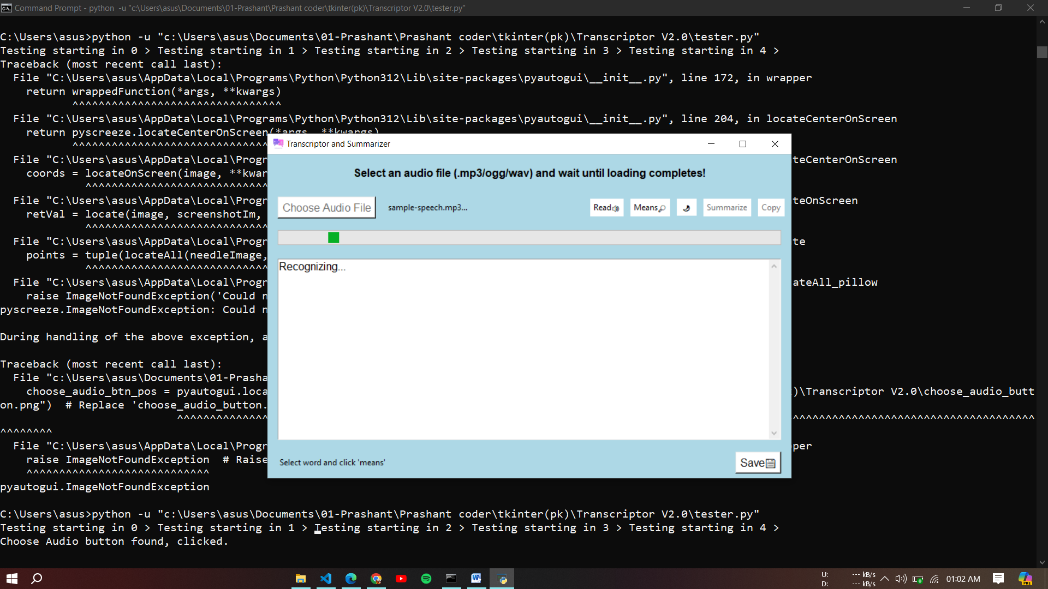

Testing file opener operation:

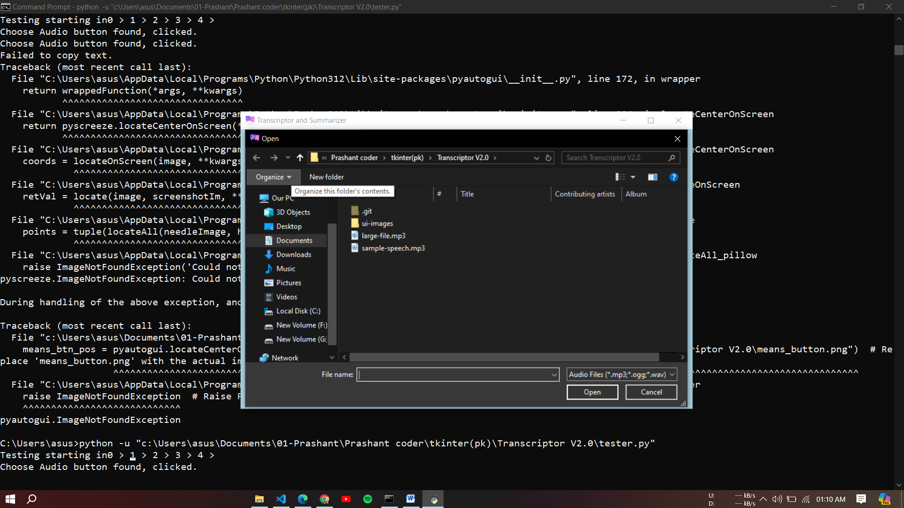

Testing copy text function:

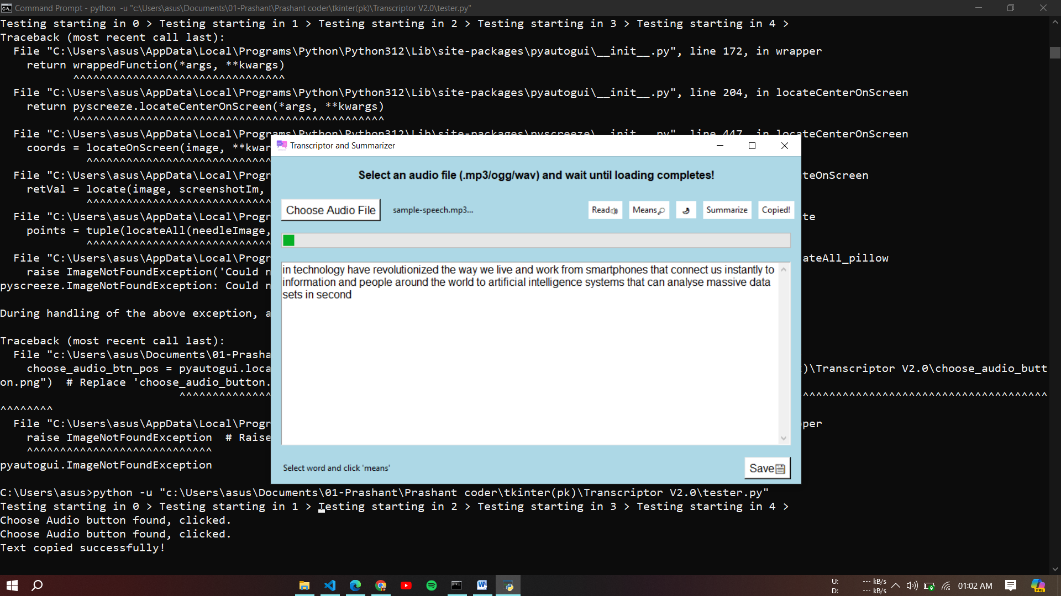

Test report

